- February 2019 variant3 task3:

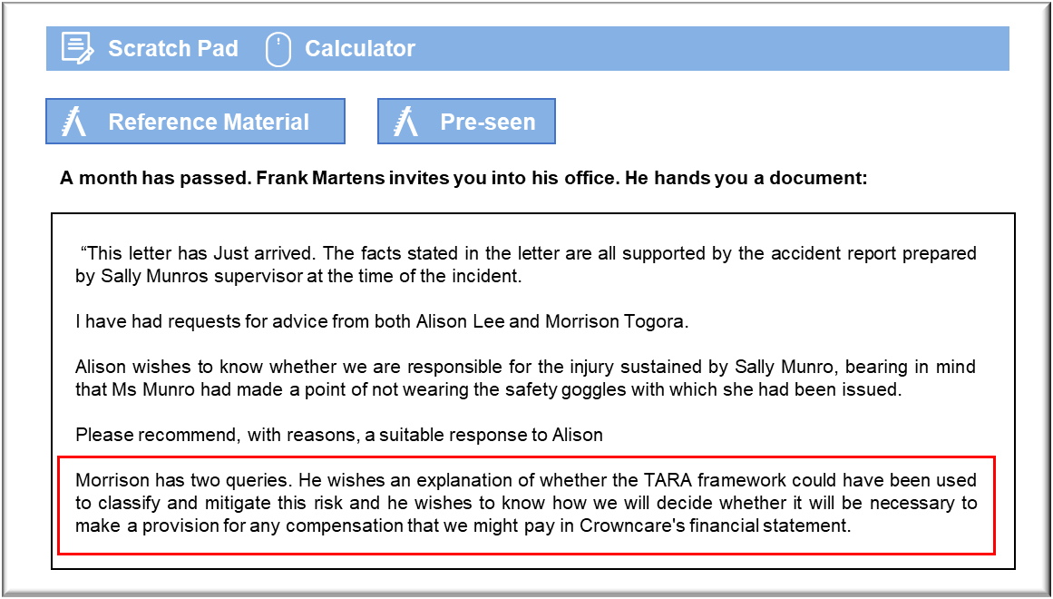

Industrial accident

Employers are generally responsible for the health and safety of their employees and it can be difficult to escape liability for an injury that has been sustained. All tasks should be subject to a risk assessment and appropriate steps taken to mitigate any risks In this case, the risk of drilling into a dental crown had been assessed and the risk of an eye injury caused by a fragment had been identified and the need to wear eye protection noted The employee should then have been briefed and provided with training in the safe operation of the equipment, including the safety precautions.

The fact that all of the necessary steps had been taken by Tonlabs, including the provision of approved safety goggles, is effectively proof that the risks were known and understood by the company. That created a duty to ensure that the employee was provided with a safe working environment, including proper supervision. Sally was permitted to work with a hand piece despite the fact that she was not wearing the necessary safety equipment and so it will be extremely difficult for Tonlabs to argue that it has not been negligent. The supervisor compounded that by giving misleading and invalid advice about the use of ordinary spectacles as eye protection.

As an employee, Sally has a legal duty to consider her own safety and that of her coworkers. If the eye protection that Tonlabs had issued was unsuitable then she should have insisted on its replacement and should have asked to be assigned to another task until a safe replacement was forthcoming. Employers cannot, however, permit employees to endanger themselves, even if those employees are aware of the risks and are exposing themselves voluntarily. The fact that others were in the habit of taking the same risk as Sally simply increases Tonlab’s responsibility to have taken action,

TARA/provision

The TARA framework would have classified this as a low probability, high consequence risk. The fact that staff frequently undertake this task without eye protection demonstrates that the likelihood of fragments causing injury is relatively low. The consequences of an employee suffering an eye injury are, however, serious. According to the TARA framework, this injury should be addressed by transferring or sharing it, perhaps through insurance.

In this case, the mechanical application of TARA would not have helped Crowncare to reach an optimal response to this risk. First of all, Crowncare’s insurers might refuse to offer cover for claims that are attributable to negligence and any claim for compensation might be rejected if negligence was an issue. Secondly, the only other stakeholders with whom to share this risk would be the employees who were exposed to the risk of injury and the law does not permit employers to permit their staff to be at risk. In this case, the response should have been for Tonlabs to have enforced its own safety procedures, thereby avoiding the risk.

The question of whether a provision is necessary depends on the likelihood that Crowncare will have to pay compensation and the extent to which that compensation can be estimated reliably. These are the criteria set out in IAS 37 Provisions, Contingent Liabilities and Contingent Assets.

The question of likelihood should be discussed with Crowncare’s lawyers. The employee may find it difficult to prove a case in court, especially when taking account of the fact that she may not be able to afford the legal costs involved. Having said that, it could raise a great deal of negative publicity for Crowncare if it is seen to make an inadequate response to the employee over this matter.

Legal cases are generally settled by negotiation, outside of the court. Again, Crowncare’s lawyers will be able to advice on the extent to which a payment can be estimated. The claim for loss of earnings should be a relatively easy figure to estimate. The question of compensation for pain and suffering is more subjective.

